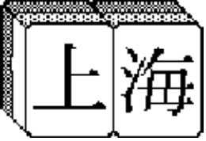
SHANGHAI '98
TILE SETS

TILE SET INTENDED AUDIENCE

MAH-JONGG GROWNUPS
ASTROLOGY GROWNUPS
EGYPTIAN GROWNUPS
ALPHABET KIDS
HOUSEHOLD OBJECTS KIDS
MATH KIDS
FANTASY EVERYBODY
OUTER SPACE EVERYBODY
PREHISTORIC EVERYBODY

Mah-Jongg
This tile set needs little explanation since it's the staple of Shanghai. The tile set is actually intended for use in the game of Mah-Jongg, of course, so it consists of 3 suits (Dots, Bams, Craks) of 1-9 (four tiles of each) plus a 4th suit (of sorts) called the "Honors" tiles: 3 different color Dragons, 4 Winds (four tiles of each), plus 4 Seasons and 4 Flowers (one tile of each). We could consider it 4 suits of 9 tiles each, multiplied by 4 = 144.

Bamboo suit:

1-4. 1 Bam (Peacock)
5-8. 2 Bam
9-12. 3 Bam
13-16. 4 Bam
17-20. 5 Bam
21-24. 6 Bam
25-28. 7 Bam
29-32. 8 Bam
33-36. 9 Bam

Dots suit:

37-40. 1 Dot
41-44. 2 Dot
45-48. 3 Dot
49-52. 4 Dot
53-56. 5 Dot
57-60. 6 Dot
61-64. 7 Dot
65-68. 8 Dot
69-72. 9 Dot

Craks suit:

73-76. 1 Crak
77-80. 2 Crak
81-84. 3 Crak
85-88. 4 Crak
89-92. 5 Crak
93-96. 6 Crak
97-100. 7 Crak
101-104. 8 Crak
105-108. 9 Crak

Winds:

109-112. East
113-116. West
117-120. North
121-124. South

Dragons:

125-128. Red
129-132. Green
133-136. White

Seasons special group:

137. Spring
138. Summer
139. Autumn
140. Winter

Flowers special group:

141. Orchid
142. Plum
143. Chrysanthemum
144. Bamboo

Astrology
This tile set is expected to be popular with Shanghai's female audience (grownups). The set combines European astrology, Chinese astrology, and the months of the year. We dropped the Hindu astrology idea.

Western Astrology Zodiac Symbols (four tiles each):

1-4. Aries
5-8. Taurus
9-12. Gemini
13-16. Cancer
17-20. Leo
21-24. Virgo
25-28. Libra
29-32. Scorpio
33-36. Sagittarius
37-40. Capricorn
41-44. Aquarius
45-48. Pisces

Chinese Zodiac Symbols (four tiles each):

49-52. Rat
53-56. Ox
57-60. Tiger
61-64. Rabbit
65-68. Dragon
69-72. Snake
73-76. Horse
77-80. Ram
81-84. Monkey
85-88. Rooster
89-92. Dog
93-96. Boar

Months of the year (four tiles each):

97-100. January
101-104. February
105-108. March
109-112. April
113-116. May
117-120. June
121-124. July
125-128. August
129-132. September
133-136. October
137-140. November
141-144. December
Egyptian
This tile set will consist of hieroglyphics and pictographs typically associated with ancient Egyptian carvings, wall paintings, and scrolls.

Egyptian Gods & Goddesses

1-4. Osiris
5-8. Isis
9-12. Horus
13-16. Anubis
17-20. Re (Ra)
21-24. Nephthys
25-28. Seth
29-32. Path
33-36. Ma'at
37-40. Amon (Amun)
41-44. Hapi
45-48. Sobek (Sebek)

Symbolic objects (wall painting)

49-52. Udjat Magic Eye of Horus
53-56. Ba
57-60. Ka
61-64. Steps
65-68. Lotus
69-72. Shen
73-76. Knot of Isis
77-80. Djed Column
81-84. Shabti Figure One (Shawabti)

Hieroglyphs

85-88. Boat
89-92. To Fly
93-96. King
97-100. Mummy
101-104. Mummy Wrapping
105-108. Thebes
109-112. Tomb
113-116. Egyptian Vulture
117-120. Flower
121-124. Great
125-128. Water
129-132. Twisted Flax
133-136. Crocodile

Special group: Canopic jars (all 4 have identical BG color):

137. Falcon jar
138. Female jar
139. Jackal jar
140. Baboon jar

Special group: Artifacts (all 4 have identical BG color):

141. Ankh
142. Scarab
143. Tut mask
144. Nefertiti bust

Alphabet
The new thing about this alphabet tile set from previous alphabet sets is that now it's a pairs-based set. Instead of all the B tiles looking alike, one pair is capital B's, the other is lower-case b's. The exceptions are the A, the Z, and the numbers.
The A and Z are both "special" foursomes akin to the Flowers and Seasons tiles. For these, there will be a block capital, a block lower-case, a script capital, and a script lower-case.
Each letter tile, when matched, will turn into an object beginning with that letter. For more info on what these objects are, see the "Assets Template" file, which will evolve as the project progresses.
For the numbers, we just have an Arabic numeral large on the tile, with a small Japanese (Chinese) numeral in the upper right corner.
The tile numbers (left column) are meaningless and can be ignored for the most part.

Red suit:

140-144. A (special group: UC block, lc block, UC script, lc script)
5-8. B
9-12. C
13-16. D
17-20. E
21-24. F
25-28. G
29-32. H
33-36. I

Blue suit:

37-40. J
41-44. K
45-48. L
49-52. M
53-56. N
57-60. O
61-64. P
65-68. Q
69-72. R

Yellow suit:

73-76. S
77-80. T
81-84. U
85-88. V
89-92. W
93-96. X
97-100. Y
137-140. Z (special group: UC block, lc block, UC script, lc script)
105-108. 0 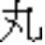

Green suit:

109-112. 1 
113-116. 2 
117-120. 3 
121-124. 4 
125-128. 5 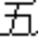
129-132. 6 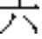
133-136. 7 
1-4. 8 
101-104. 9 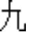

See picture below.

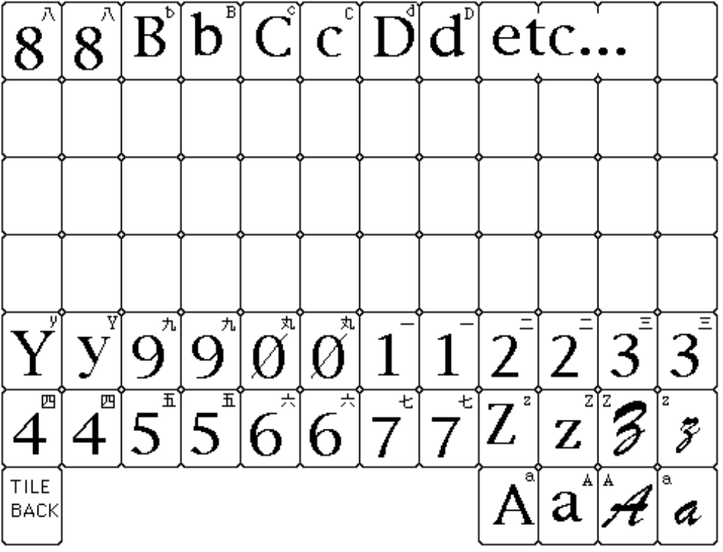

I have organized the letters and numbers within the template in… not the most logical fashion. I only did this because I was re-working an existing template, and was too lazy to re-organize everything.
Household objects
It's expected that this tile set will be of interest mainly to kids (note: it's silly for me to have broken them down in suits, but I was having fun). It is fine to just do exactly what is outlined below, or we may think of other objects which would be more fun.

Bedroom objects:

1-4. Socks
5-8. Shoes
9-12. Shirt
13-16. Alarm clock
17-20. Lamp
21-24. Doll
25-28. Action figure
29-32. Teddy Bear
33-36. Beach ball

Kitchen objects:

37-40. Pair: Salt, Pepper
41-44. Coffee maker
45-48. Silverware (special group)
49-52. Potholder mitt
53-56. Dish detergent
57-60. Sponge
61-64. Blender
65-68. Toaster
69-72. Pots & pans (special group)

Bathroom objects:

73-76. Toilet scrubber
77-80. Plunger
81-84. Hair Dryer
85-88. Toothbrush
89-92. Toilet paper
93-96. Rubber ducky
97-100. Toy submarine
101-104. Soap
105-108. Comb

Workshop objects:

109-112. Hammer
113-116. Saw
117-120. Screwdriver
121-124. Wrench
125-128. Pliers
129-132. Electric drill
133-136. Snow shovel
137-140. Paintbrush
141-144. Rake
MATH TILE SET - for kids' game
Tiles are comprised of simple math problems and their answers. For example, user can click on a "1+1" tile, then on a "2" tile. There are a total of 36 problem tiles and a total of 36 matching answer tiles. John Harris of Creative Affairs helped out with these "problems and solutions."

1x1 | 1
1+1 | 2
5-2 | 3
2x2 | 4
10/2 | 5
1+5 | 6
3+4 | 7
2x4 | 8
4+5 | 9
5x2 | 10
10+1 | 11
4x3 | 12
6+7 | 13
20-6 | 14
5x3 | 15
4x4 | 16
18-1 | 17
9+9 | 18
7+12 | 19
40/2 | 20
7x3 | 21
11x2 | 22
11+12 | 23
12X2 | 24
5x5 | 25
18+8 | 26
9x3 | 27
14x2 | 28
14+15 | 29
10+20 | 30
27+4 | 31
4x8 | 32
11x3 | 33
40-6 | 34
7x5 | 35
6x6 | 36

Notes from Tom:
My thinking on this set is that:
(1) It's not something kids will want to play; they'll only play it while Mommy is sitting right there with them. I worry it'll make kids not want to play the game at all.
(2) Shanghai is all about matching. Matching is inherently educational, but this feels like using a sledgehammer to drive a tack.
(3) If we make the game be about matching for the purpose of being educated, then it isn't fun anymore. The purpose should be to have fun. If you learn in the process, then that's fine.
(4) Regardless of the above, we should include at least one purely educational tile set in the game, because it reinforces for parents the educational potential of Shanghai. Parents will want to create their own tile sets, and maybe even kids will create their own.
(5) We need to make these tiles attractive-looking, not dry and dull.
(6) The larger the answer, the more difficult the problem -- thus we might want to fix it so that for younger kids (those who would be using layouts of fewer tiles) only the easier problems come up -- but to do this would reduce the variety in the other tile sets (if the rule applied to all tile sets). So we won't do anything special like that; the answers are as easy as they can be given that the highest result is 36 and we are including multiplication and division (not just addition and subtraction).
Fantasy
Something about knights, damsels, trolls, wizards, and dragons enchants the young and old alike. The 2nd-most-popular tile set in Sh2DE, we'll do a slightly different take on it this time, combining elements of Renaissance Faire, Tarot cards, and D&D-style characters and objects. I have intentionally done away with the "suits" so as to get the best possible tile set. There is no need to break these down into "monsters" and "characters" and "objects" and such.

1-4. Wizard
5-8. Dragon
9-12. Unicorn
13-16. Treasure
17-20. Death w/ his scythe
21-24. Minstrel
25-28. Headsman
29-32. Gargoyle
33-36. Magic Spell Book
37-40. Iron Maiden; or: Rack; or: prisoner hanging from shackles in dungeon
41-44. Black Knight
45-48. White Knight / Crusader
49-52. Warhorse in jousting gear (head shot maybe)
53-56. Friar
57-60. Fool (a beggar with all his belongings in a sack hanging from a stick over his shoulder, about to step off a cliff; very different from a Jester)
61-64. Holy Grail
65-68. Crystal Ball
69-72. King
73-76. Queen
77-80. Princess
81-84. Page boy w/ tunic and "pageboy bob" haircut
85-88. Jester / Joker
89-92. Ogre (big, maybe greenish creature)
93-96. Dwarf (note: Dwarves are short and bearded, and are fierce fighters)
97-100. Skeleton with crown ("Lich"?)
101-104. Shadow Demon
105-108. Blue Elven Sword (à la Zork)
109-112. Elf (note: Elves are tall and attractive, with almond eyes, blond hair and magical powers)
113-116. Harpy (bird with woman's head; very ugly)
117-120. Rat
121-124. Castle
125-128. Body on a stick
129-132. Succubus (she should be attractive, with bat wings)
133-136. Minotaur

Special group: Musical Instruments
137. Lyre or Lute
138. Psaltry (?) or Hornpipe
139. Hurdy Gurdy
140. Tamborine or Shawn

Special group: Shields
141. Square shield w/ Lion or Griffin
142. Single swoop shield w/ Falcon, wings outstretched
143. Double swoop shield w/ Snakes entwined
144. Oval bottom shield w/ menacing-looking Knight's helmet

Outer Space
A tile set that's bound to appeal to grownups and kids alike. I have indicated tiles to fit into four arbitrary "suits" but this is not necessary. Feel free to expand, and to violate the "suits" paradigm as you see fit.

Planets suit:

1-4. Mercury
5-8. Venus
9-12. Earth
13-16. Mars
17-20. Jupiter
21-24. Saturn
25-28. Uranus
29-32. Neptune
33-36. Pluto

Space vehicles suit (freely choose from real and imaginary vehicles):

37-40. Toy rocket
41-44. Gleaming rocket
45-48. Saucer
49-52. Shuttle
53-56. Apollo
57-60. Mercury capsule
61-64. L.E.M.
65-68. Sputnik
69-72. Skylab or Hubble Telescope

Aliens suit

73-76. Grey
77-80. Martian
81-84. Android
85-88. Insect-like alien
89-92. Reptilian alien
93-96. Half-man half-machine
97-100. Blob w/ antennae
101-104. Robot
105-108. Big-head robed guy

"More space stuff" suit (broken down like Honors):

109-112. SPECIAL GROUP: The Moon (Man-In-The-Moon, Moon Landing, Crescent, Full)
113-116. SPECIAL GROUP: Comets (4 different ones)
117-120. Nebula 1
121-124. Nebula 2
125-128. Nebula 3
129-132. Nebula 4
133-136. Galaxy 1
137-140. Galaxy 2
141-144. Galaxy 3
Prehistoric
We did a tile set like this for the Genesis version of Shanghai II: Dragon's Eye. It deserves a wider audience. Below I just list the tiles we did in the Genesis game -- we can certainly create just about anything we want in this new tile set. The tiles marked "must keep" are those objects and animals which must be represented without fail. Anything NOT marked "must keep" can certainly be replaced by anything that is cooler. See the next page for more new ideas.

1-4. Tyrannosaurus Must keep
5-8. Plateosaurus
9-12. Stegosaurus Must keep
13-16. Ornithosuchus
17-20. Pteradactyl Must keep
21-24. Triceratops Must keep
25-28. Apatosaurus Must keep
29-32. Lambeosaurus
33-36. Parasaurolophus
37-40. Leptoceratops
41-44. Pentaceratops
45-48. Thescelosaurus
49-52. Egg Must keep
53-56. Velociraptor Must keep
57-60. Psittacosaurus
61-64. Sabertooth Tiger Must keep
65-68. Gerrothorax
69-72. Wooly Mammoth Must keep
73-76. Placochelys
77-80. Caveman Must keep
81-84. Volcano Must keep
85-88. Harpagornis Moorei
89-92. Arrowhead
93-96. Club Must keep
97-100. Cave Painting Must keep
101-104. Torch Must keep
105-108. Stone Axe
109-112. Dinosaur Footprint
113-116. Trilobite Must keep
117-120. Cro-Magnon Skull Must keep
121-124. Fossilized Coelacanth
125-128. Leg bone
129-132. Nautilus
133-136. Horseshoe Crab

Special groups (feel free to change these to something else, folks!)

137-140. Insects -- Meganeura, Pusiotis, Trigonopeltastes, Photinus
141-144. Plants -- Pterophyllum, Araucarites, Echinostrobus, Zamites

Here are some more favorite prehistoric ideas, added by John Harris:

Plesiosaur (a la "Nessie")
Monolith :-)
Tar pit
Glacier
Volcano (assuming it's not the reward)
Brontosaurus
That spitting dino from "Jurassic Park"
Gallimimus (the one in "Jurrasic Park" that they first saw running through the field)
Diplodocus
Allosaurus
Thesaurus :-)
Cave Bear
Some sort of prehistoric-lookin' fish
Fire
Loincloth
Evolving creature trudging up out of the ocean
Hunter
Gatherer

Let's have fun with this tile set!

Notes by Tom:
Let's remember that the normal tile set is comprised of 36 foursomes. 34 of the foursomes normally are exactly identical, and normally the remaining 2 foursomes are not identical. It is also possible, within the template, to create a set of 36 twosomes. See the example template below.

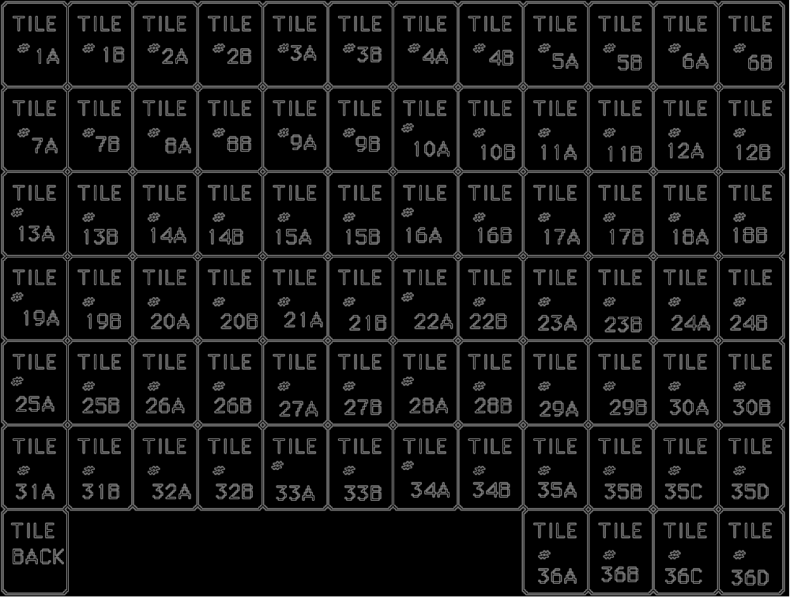

Re animations – there will be a maximum of 36 animations per tile set. So for the Flowers and Seasons (tiles 35 and 36) although there are 4 unique tiles, matching any two of them always causes a single animation to occur.
A question for Quicksilver to resolve is how to deal with situations in which a tile is perhaps not associated with an animation, or multiple different tiles are all associated with the same animation (do we copy an animation multiple times?).

Presage will decide based on what makes the "easiest read."
This graphic can be used for this tile set, for the Mah-Jongg game, and for the Wild Tile power tile.
Presage will choose the 4 musical instruments based on variety of look and sound, as well as easiness of reading.
John Harris likes the fact that with Lion/Griffin and Falcon being "good" or "awe-inspiring," the other two motifs can represent the "dark side," as it were.
Note: I may be confused on this, but I believe the apatosaurus has now replaced the bronto, which it turns out was not a real animal after all?

